Remote Procedure Call (RPC)
In distributed computing a remote procedure call (RPC) is when a computer program causes a procedure (subroutine) to execute in another address space (commonly on another computer on a shared network), which is coded as if it were a normal (local) procedure call, without the programmer explicitly coding the details for the remote interaction. That is, the programmer writes essentially the same code whether the subroutine is local to the executing program, or remote. This is a form of client–server interaction (caller is client, executer is server), typically implemented via a request–response message-passing system.
RPCs are a form of inter-process communication (IPC), in that different processes have different address spaces: if on the same host machine, they have distinct virtual address spaces, even though the physical address space is the same; while if they are on different hosts, the physical address space is different.

How RPC Works
RPC is a kind of request–response protocol. An RPC is initiated by the client, which sends a request message to a known remote server to execute a specified procedure with supplied parameters. The remote server sends a response to the client, and the application continues its process. While the server is processing the call, the client is blocked (it waits until the server has finished processing before resuming execution), unless the client sends an asynchronous request to the server, such as an XHTTP call. There are many variations and subtleties in various implementations, resulting in a variety of different (incompatible) RPC protocols.
An important difference between remote procedure calls and local calls is that remote calls can fail because of unpredictable network problems. Also, callers generally must deal with such failures without knowing whether the remote procedure was actually invoked.
RPC Process
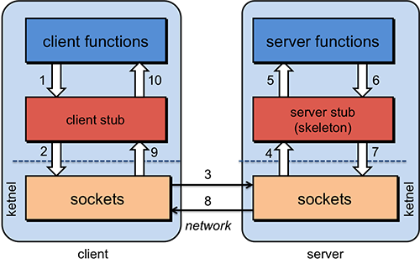
Fig. RPC Process
Stub = piece of code that converts parameters passed between client and server
- The client calls a local procedure, called the client stub. To the client process, this appears to be the actual procedure, because it is a regular local procedure. It just does something different since the real procedure is on the server. The client stub packages the parameters to the remote procedure (this may involve converting them to a standard format) and builds one or more network messages. The packaging of arguments into a network message is called marshaling and requires serializing all the data elements into a flat array-of-bytes format.
- Network messages are sent by the client stub to the remote system (via a system call to the local kernel i.e. client OS using sockets interfaces).
- Network messages are transferred by the kernel to the remote system via some protocol (either connectionless or connection-oriented).
- A server stub, sometimes called the skeleton, receives the messages on the server. It unmarshals the arguments from the messages and, if necessary, converts them from a standard network format into a machine-specific form.
- The server stub calls the server function (which, to the client, is the remote procedure), passing it the arguments that it received from the client.
- When the server function is finished, it returns to the server stub with its return values.
- The server stub converts the return values, if necessary, and marshals them into one or more network messages to send to the client stub.
- Messages get sent back across the network to the client stub.
- The client stub reads the messages from the local kernel.
- The client stub then returns the results to the client function, converting them from the network representation to a local one if necessary.

